Introduction

The system we are working on is basically the HR management system. The main entities that are part of the HR management system are as follows:

* HR Manager
* Employee
* Clients
* Performance reviews
* Salaries
* Increments
* Deduction

### Dataset:

We have not used any kind of dataset available online. We gave priority to make our own database of the System mentioned above and we were guided several times by our Professor Dr. Abid throughout the project.

### How the System will Work?

The system is basically the HR management system in which there are thousands of employees work at the same time. We will generate the data of almost 10 years. Each of the main entities mentioned above has its own importance and plays a significant role in the whole system. Following are the entities along with their some of the main functionalities.

### HR Manager:

HR manager is also an employee. HR manager will have all the attributes like a normal employee. The Salary of the HR Manager is mentioned in the Job Titles as there are total of 139 job titles for different employees. An HR manager can see the comments and reviews given by the clients and give his own comments too.

### Employee:

An employee has different attributes like name (can be first name and last name together), address, basic salary, job titles etc. Employee is of some type defined in the “Employee Type “column. Employee has a working status that can be either 0 or 1 and this will reflect whether the employee is still working or left the job. Employee has a salary and after each job assignment, employees are given reviews by the clients and on the basis of these reviews, employee gets an increment if it meets the requirement.

### Performance Reviews:

After every job assignment, employee is given a review and these reviews are annually calculated according to a decided formula. If the review’s ratio is 50% or above, that specific employee will get an increment in one’s salary.

### Clients:

Client is a simple entity having some common attributes like name, address, phone number, email etc. Client is capable of giving at most one rating and one review per job assignment.

### Salary:

Salary is one of the most important entity of the whole system as it contains the numeric data that can be aggregated. So, this will be our first and main transactional entity. Salary is given to employees on monthly basis employees and there is a possibility of salary increment after exactly one year if the rating’s ratio of a particular employee meets the target which is at least 50%.

### Deduction:

Two types of tax deductions are set. One is of 10% of the basic salary and second one is of 2% of the basic salary. Both of the deductions are on monthly basis. Salary comes from salary table and then deduction is applied.

### Increments:

Increment table calculates the increment amount of a specific employee that is working for one year. The criteria for incrementing in a salary is simple. If the annual ratings of the employee have a ratio of 50% or above, employee will have an increment in the basic salary. Below is the criteria table according to which increments will be calculated.

|  |  |
| --- | --- |
| **Percentage of Ratings Calculated Annually** | **Increment in the Basic Salary (Percentage)** |
| 50-59% | 5-5.9% |
| 60-69% | 6-6.9% |
| 70-79% | 7-7.9% |
| 80-89% | 8-8.9% |
| 90-100% | 9-10% |

ERD (Entity Relation Diagram)

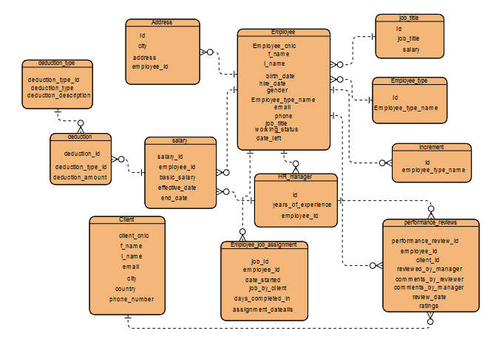

# Employee_Type

create table employee_type(

id int not null identity primary key,

employee_type_name varchar(15);

# Employee_Job_Assignment

create table employee_job_assignment(

job_id int not null identity primary key,

employee_id varchar(25) foreign key references employee(employee_cnic),

date_started date,

days_completed_in int,

assignment_details varchar(300),

job_by_client varchar(25) foreign key references client(client_cnic)

);

insert into employee_job_assignment (employee_id,date_started,assignment_details,job_by_client,days_completed_in) select employee_id, review_date,comments_by_reviewer,client_id,RAND()*(90-30)+30 from performance_reviews ;

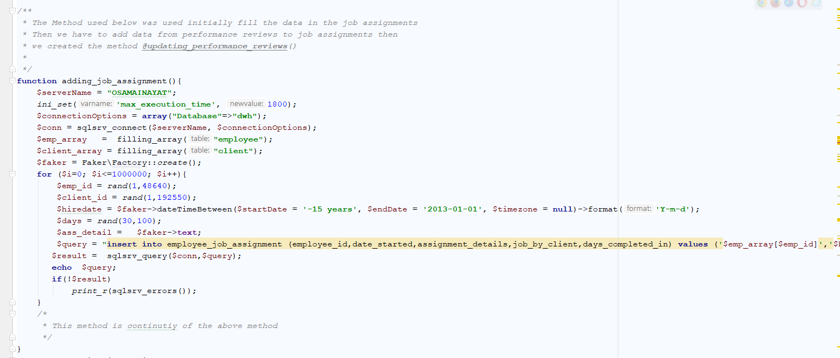

# Employee

create table employee (

employee_cnic varchar(25) not null primary key,

f_name varchar(10),

l_name varchar(10),

birth_date date,

hire_date date,

gendre varchar(6),

employee_type_name int foreign key references employee_type(id)

);

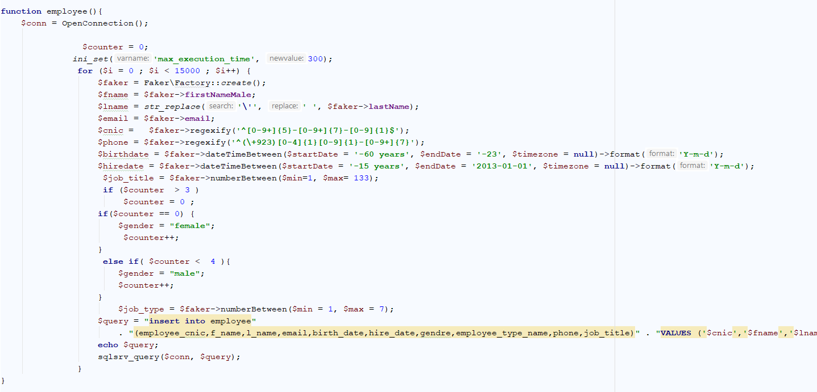

alter table employee add job_title int;

alter table employee add foreign key (job_title) references job_title(id);

GO

CREATE PROCEDURE selectEmployee @employee_cnic nvarchar(30)

AS

SELECT *

FROM employee

WHERE employee_cnic = @employee_cnic

GO

exec selectEmployee @employee_cnic='00009-6482451-2';

alter table employee alter column f_name varchar(25);

alter table employee alter column l_name varchar(25);

alter table employee drop column job_title;

alter table employee add email varchar(45);

alter table employee add phone varchar(20);

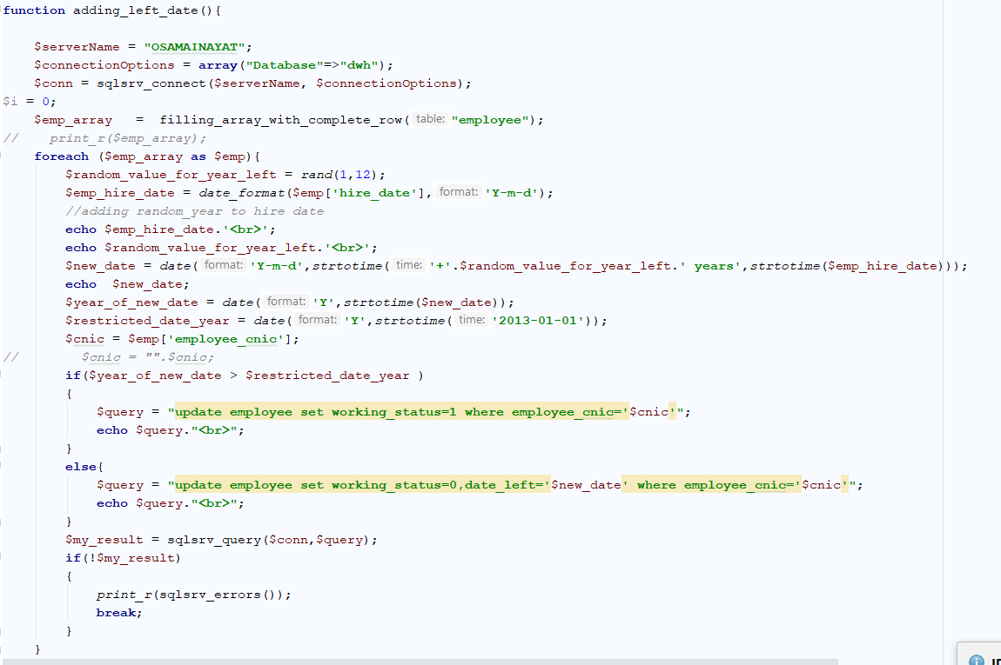

# HR_Manager

create table Hr_Manager (

id int not null identity primary key,

years_of_experience float(6),

employee_id varchar(25) foreign key references employee(employee_cnic)

);

alter table Hr_Manager drop column job_titles;

select * from hr_manager;

alter table Hr_manager add Job_titles varchar(30);

alter table employee add Job_titles varchar(30);

insert into Hr_Manager (employee_id) select employee_cnic from employee where job_title=83;

# Performance_Reviews

create table performance_reviews(

performance_review_id int not null identity primary key,

employee_id varchar(25) foreign key references employee(employee_cnic),

client_id varchar(25) foreign key references client(client_cnic),

reviewed_by_manager int foreign key references hr_manager(id),

comments_by_reviewer varchar(300),

comments_by_manager varchar(300)

);

alter table performance_reviews add review_date date;

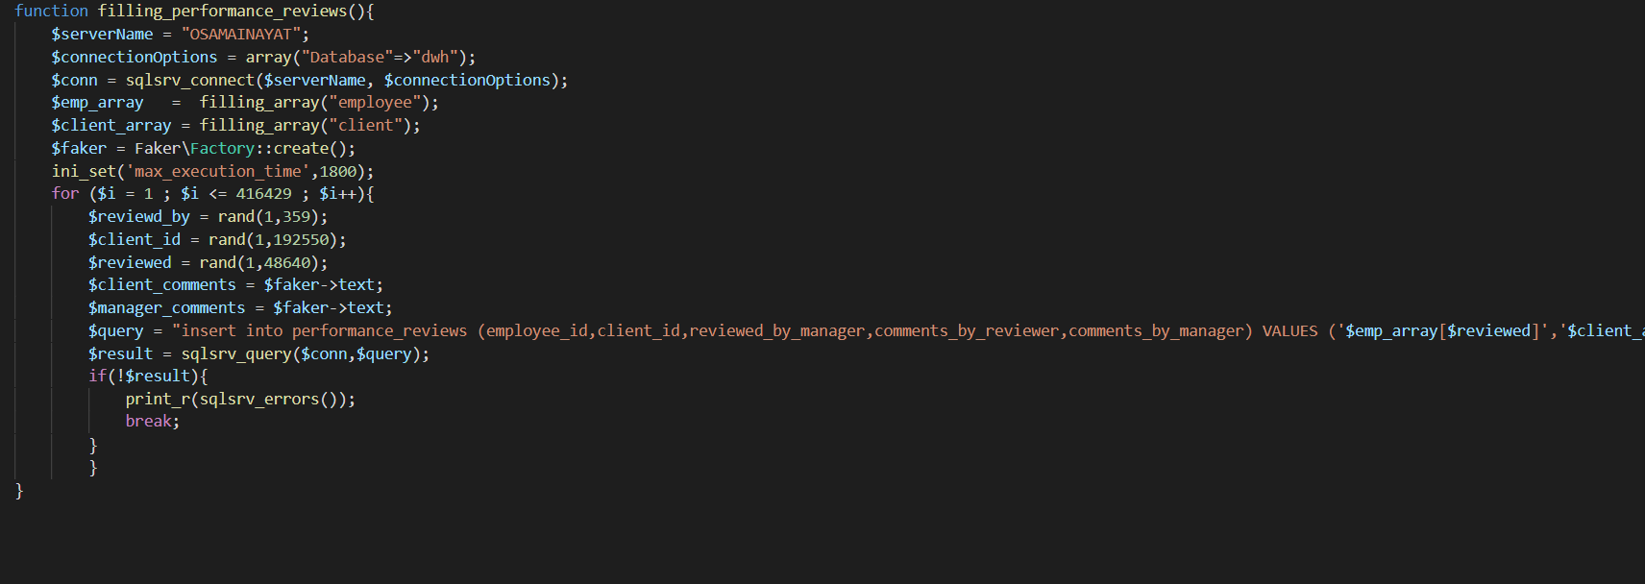

# Deduction_Type

create table deduction_type(

deduction_type_id int not null identity primary key,

deduction_type varchar(50),

deduction_description varchar(200)

);

insert into deduction_type (deduction_type,deduction_description) values('General TAX','MONTHLY INCOME TAX');

insert into deduction_type (deduction_type,deduction_description) values('GP TAX','GP TAX');

# Deduction

create table deduction(

deduction_id int not null primary key identity,

deduction_type_id int foreign key references deduction_type(deduction_type_id),

deduction_amount float,

salary_id int foreign key references salary(salary_id)

);

insert into deduction(salary_id,deduction_amount) select salary_id,basic_salary from salary;

select * from salary;

SELECT * FROM increments;

select * from deduction_type;

select * from deduction;

update deduction set deduction_type_id=2 where deduction_type_id IS NULL ;

select * from deduction

update deduction set deduction_amount = (0.01*deduction_amount) where deduction_type_id = 2;

# Client

create table client(

client_cnic varchar(25) primary key,

f_name varchar(15) not null,

l_name varchar(15) not null,

email varchar(35) not null,

city varchar(30),

country varchar(30),

phone_number varchar(30)

);

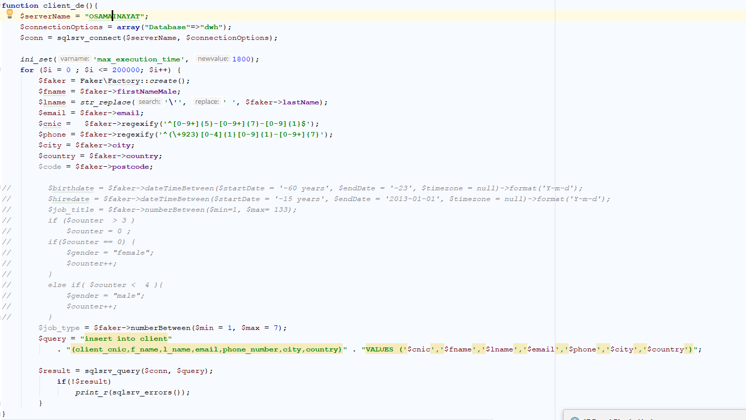

# Job_Title

create table job_title(

id int not null identity primary key,

job_title varchar(60)

);

# Salary

create table salary(

salary_id int not null identity primary key,

employee_id varchar(25) foreign key references employee(employee_cnic),

basic_salary float not null,

effective_date date,

end_date date,

approved_by_manager int foreign key references Hr_Manager(id)

);

GO

Create procedure adding_salaries

@hire_date date,@temp_year int,@emp_cnic varchar(25),@salary float,

/*INCREMENT ARGUMENTS*/

@number_of_ratings int,@sum_of_ratings int,@manager int

AS

DECLARE @ending_date date;

DECLARE @i int = 1;

WHILE (@i <= 12)

BEGIN

SET @ending_date = DATEADD(MONTH,1,@hire_date);

insert into salary (employee_id,basic_salary,effective_date,end_date,approved_by_manager)

values(@emp_cnic,@salary,@hire_date,@ending_date,@manager);

SET @hire_date = DATEADD(DAY,1,@ending_date);

SET @i = @i+1;

END

IF(@number_of_ratings > 0 )

BEGIN

DECLARE @increment_percentage float;

SET @increment_percentage = (CAST(@sum_of_ratings as float)/CAST((@number_of_ratings*10 ) as float))*100;

IF(@increment_percentage > 50 )

BEGIN

DECLARE @increment_year int = YEAR(@hire_date);

DECLARE @increment float = (Cast((@increment_percentage/1000) as float))*CAST(@salary as float);

SET @salary = @salary+@increment;

insert into increments(employee_cnic,increment_year,increment,salary_after_increment) values (@emp_cnic,@increment_year,@increment,@salary);

END

END

**GO**

**exec adding_salaries @hire_date='2008-08-21',@temp_year='2008',@emp_cnic='00012-9027189-6',@salary='75000',@number_of_ratings='1',@sum_of_ratings='9';**

**GO**

**create procedure updating @basic_salary float, @employee_id varchar (25) , @effective_date date, @end_date date**

**AS**

**update salary set basic_salary=@basic_salary where employee_id=@employee_id and effective_date=@effective_date**

**and end_date=@end_date;**

**GO**

**CREATE PROCEDURE updating_salary @year int ,@employee_cnic nvarchar(30)**

**AS**

**select count(ratings) as number_of_ratings,sum(ratings) as sum_of_ratings from performance_reviews**

**where year(review_date)=@year and employee_id=@employee_cnic;**

**GO**

**exec updating_salary @year=2004 , @employee_cnic='00019-8012201-7'**

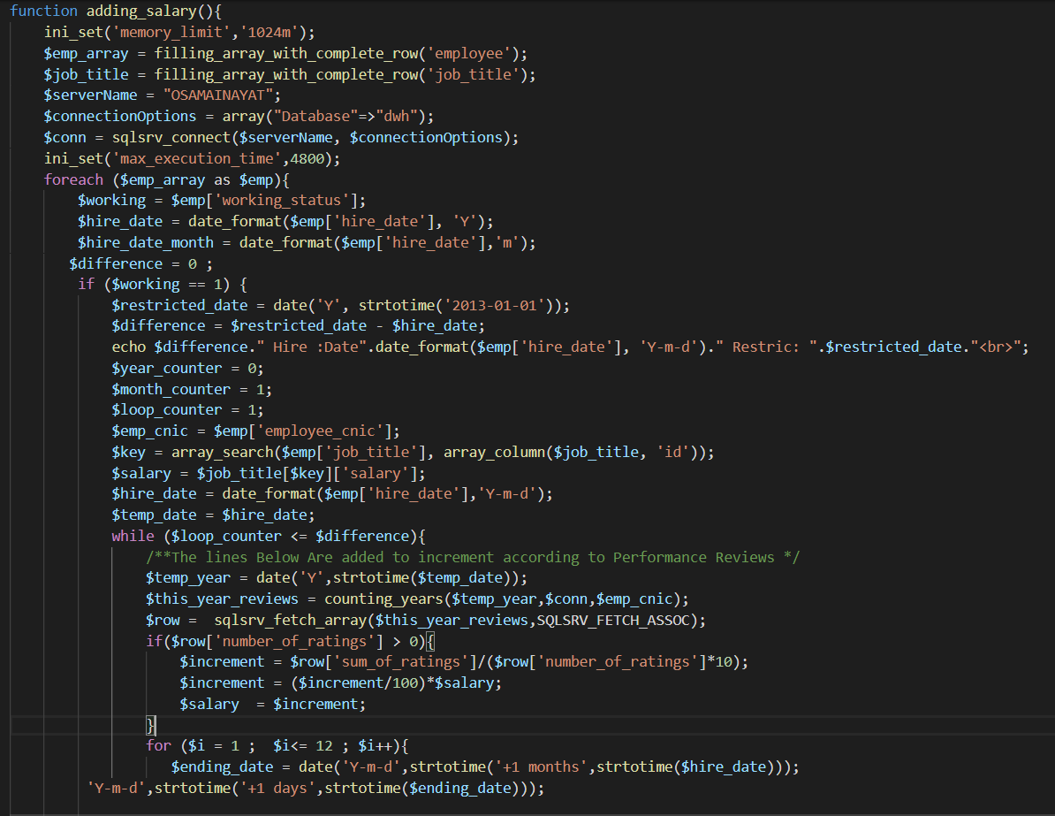

# Increments

create table increments

(id int not null identity primary key,

employee_cnic varchar(25) foreign key references employee(employee_cnic),

increment_year int, increment float, salary_after_increment float );

select * from performance_reviews;

Update increments set effective_date = (select TOP(1) effective_date from salary where basic_salary= increments.salary_after_increment and increments.employee_cnic = salary.employee_id)

GO

Create procedure adding_salaries

@hire_date date,@temp_year int,@emp_cnic varchar(25),@salary float,

/*INCREMENT ARGUMENTS*/

@number_of_ratings int,@sum_of_ratings int,@manager int

AS

DECLARE @ending_date date;

DECLARE @i int = 1;

WHILE (@i <= 12)

BEGIN

SET @ending_date = DATEADD(MONTH,1,@hire_date);

insert into salary (employee_id,basic_salary,effective_date,end_date,approved_by_manager)

values(@emp_cnic,@salary,@hire_date,@ending_date,@manager);

SET @hire_date = DATEADD(DAY,1,@ending_date);

SET @i = @i+1;

END

IF(@number_of_ratings > 0 )

BEGIN

DECLARE @increment_percentage float;

SET @increment_percentage = (CAST(@sum_of_ratings as float)/CAST((@number_of_ratings*10 ) as float))*100;

IF(@increment_percentage > 50 )

BEGIN

DECLARE @increment_year int = YEAR(@hire_date);

DECLARE @increment float = (Cast((@increment_percentage/1000) as float))*CAST(@salary as float);

SET @salary = @salary+@increment;

insert into increments(employee_cnic,increment_year,increment,salary_after_increment) values (@emp_cnic,@increment_year,@increment,@salary);

END

END

GO

Schema Modeling

# Star Schema

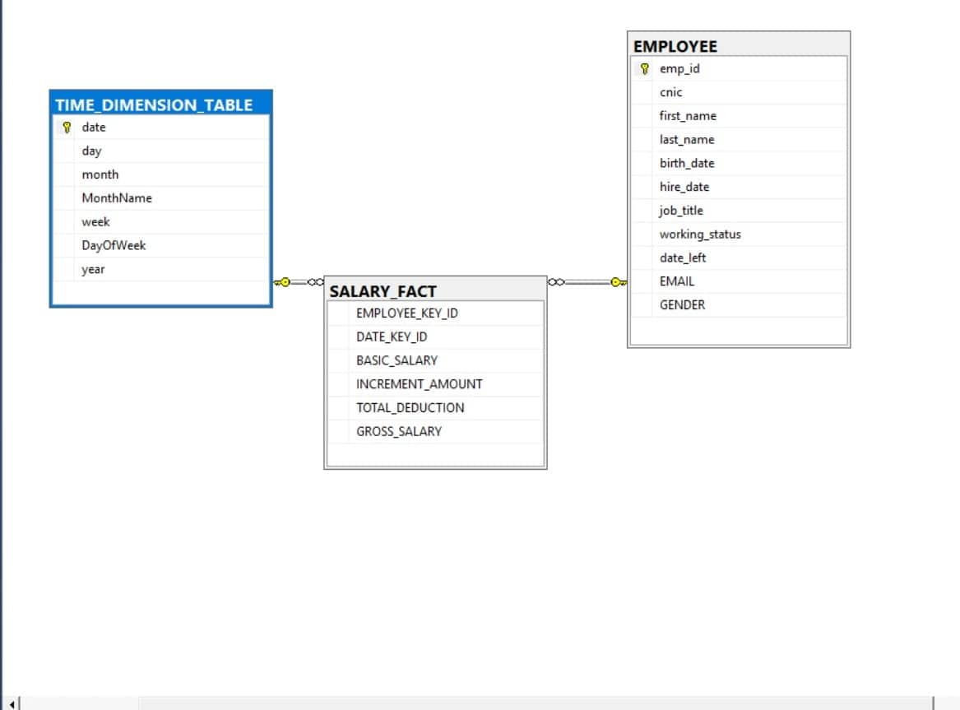

# WHY WE CHOOSE STAR SCHEMA FOR CREATING DATA WAREHOUSE ?

As we know that a **star schema** is used as a basic implementation of an OLAP cube. If the fact table contains a 1 to many relationships to each of the dimensions in the data warehouse schema then we know that it is appropriate to **use** a **star schema.** Considering our system, the dimensions are in a 1-to-many relation with the fact table. That is why we choose star schema.

The reason we are using the Star schema is due to its advantage in the decision support environment. The star schema is faster in query processing unlike others such as OLTP system.

The number of tables in a star schema are fewer and it makes it easy to understand the join paths as they are clear.

Star schema performs well in loading and administration is quite easy compare to others.

Another main reason for star schema is the built-in referential integrity.

The relations and the schema modeling can be easily understood by anyone who is not much familiar with the System.

In computing, the **star schema** is the simplest style of data mart **schema** and is the approach most widely **used** to develop data warehouses and dimensional data marts.

The **star schema** is an important special case of the snowflake **schema**, and is more effective for handling simpler queries.

Hierarchies are split into different tables (Sub Dimensions). The snowflake schemais normalized. So, the data access latency is less in **star schema** in comparison to snowflake schema. As the **star schema** is denormalized, the size of the **data warehouse** will be larger than that of snowflake schema.

Business Process Model

**Statement:**

Once an employee has completed its job assignment. Client has an option of giving ratings to an employee on the basis of job assignment which is done by employee. Each employee has a rating chart which is updated after every job assignment. If the year is completed (it’s the last assignment of the year) Increment is added to the employee’s salary on the basis of rating’s ratio after every year.

**Process model of Salary Increment**

